Input

Multiplexer

INTRODUCING THE INPUTMULTIPLEXER
The Next Step On InputProcessors
- What if we want to use multiple InputProcessors?
- We may want an InputProcessor for the keyboard and a GestureDetector
for an Android touch screen. Maybe a second InputProcessor for a
player two. Or just for organizing the code.
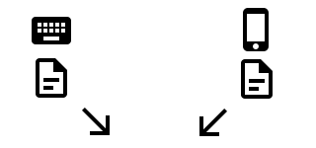
- This doesn’t work:

Gdx.input.setInputProcessor(keyboardInput);
Gdx.input.setInputProcessor(GestureInput);

Introducing the inputmultiplexer ii
Fixing The Problem
- We fix this problem with the InputMultiplexer.
- First we create the InputMultiplexer.
InputMultiplexer multiplexer = new InputMultiplexer();
- Next we add the InputProcessors.
multiplexer.addProcessor(KeyboardInput);
multiplexer.addProcessor(GestureInput);
- Finally, we set the multiplexer as the InputProcessor.
Gdx.input.setInputProcessor(multiplexer);

inputprocessor return
@Override
public boolean keyDown(int keycode) {
return false;
}
- The events return a boolean so you can decide if you want to process
the next event of the same type, or not, once you have set multiple
InputProcessors.
- If it returns true it stops, otherwise it goes to the same event type of the
next InputProcessor.

